Sprint 4 Planning

# What we got from Steve

## Previous Moves Table

* There needs to be a table where you can see the previous moves made.
* This does get weird with games such as snake, but we do not need to worry about that at this moment.

## Live Games UI

* Add the names and ELO’s of the players playing in a live game.
* At the moment, the user cannot see these details.
* If the game is cancelled because an agent crashed or their reasons, the people at the front end need to be informed of this change.

## Editing Agents

* Users need to be able to:
  + Add an agent to an open tournament.
  + Remove their agent from a tournament.
  + Upload an agent of theirs.
  + Graphical user interface

    Description automatically generated with medium confidence
  + 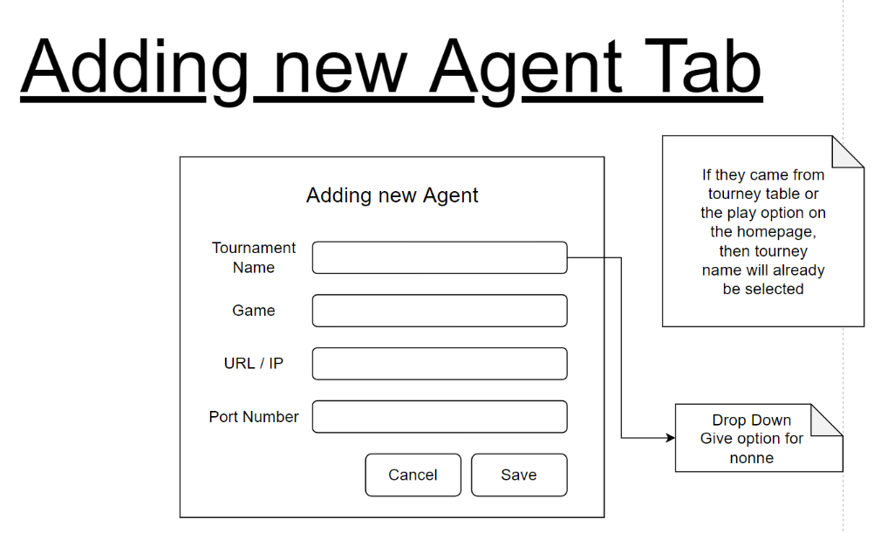
  + Diagram

    Description automatically generated

## Fix agent list.

* Currently the agent list in the user profile is incorrect. This needs to be rectified.

## Change Agent table

* Since the user decides what tournaments, their agents can participate in, we need to add a column denoting what game this agent is for.

## Add move timer.

* When running games between 2 agents, we need to add a default timer, pertaining to specific tournaments.

# Stretch Goals

## Add Admin Interface

* From this screen, the admin will be able to:
  + Create tournaments.
  + Start Tournaments.
  + End Tournaments.
  + Control who gets to play in tournaments.
  + View closed tournaments.

## More tournament brackets

* Swiss
* Round Robin

# Additional Goals

## Crete a new Logo

* The current one is fine, but maybe a picture would be nice, like the one we had for INFOs last year.
  + Logo

    Description automatically generated

## Do more with the games.

* Have tournaments running.
* Have more games than Tic-Tag-Toe.
* Have more than 2 players playing in the database.
* Change interface Steve suggested to accommodate for wider range of games.

## Implement friends / link

* Have a section in your profile that shows all your friends, so that you can better track their progress and challenge their agents more freely.